CREATE SCHEMA `finance` ;

USE finance;

CREATE TABLE cc_data (
indexnumber VARCHAR (100) NOT NULL,
transdate VARCHAR (100) NOT NULL,
cardnumber VARCHAR (100) NOT NULL,
merchant VARCHAR (100) NOT NULL,
category VARCHAR (100) NOT NULL,
amt INT NOT NULL,
firstname VARCHAR (100) NOT NULL,
lastname VARCHAR (100) NOT NULL,
gender VARCHAR (5) NOT NULL,
street VARCHAR (100) NOT NULL,
city VARCHAR (100),
state VARCHAR (5),
zip VARCHAR (10),
latitude VARCHAR (50) NOT NULL,
longitude VARCHAR (50) NOT NULL,
citypopulation INT NOT NULL,
job VARCHAR (100),
dob VARCHAR (50),
transnumber VARCHAR (100) NOT NULL,
unixtime VARCHAR (100) NOT NULL,
merchlatitude VARCHAR (100) NOT NULL,
merchlongitude VARCHAR (100) NOT NULL,
fraud INT NOT NULL
);

SELECT * FROM cc_data;

CREATE TABLE location_data (
cardnumber VARCHAR (100) NOT NULL,
latitude VARCHAR (100) NOT NULL,
longitude VARCHAR (100) NOT NULL
);

SHOW TABLES FROM finance;

SELECT * FROM cc_data;
SELECT * FROM location_data;

SELECT COUNT(*)
FROM cc_data;
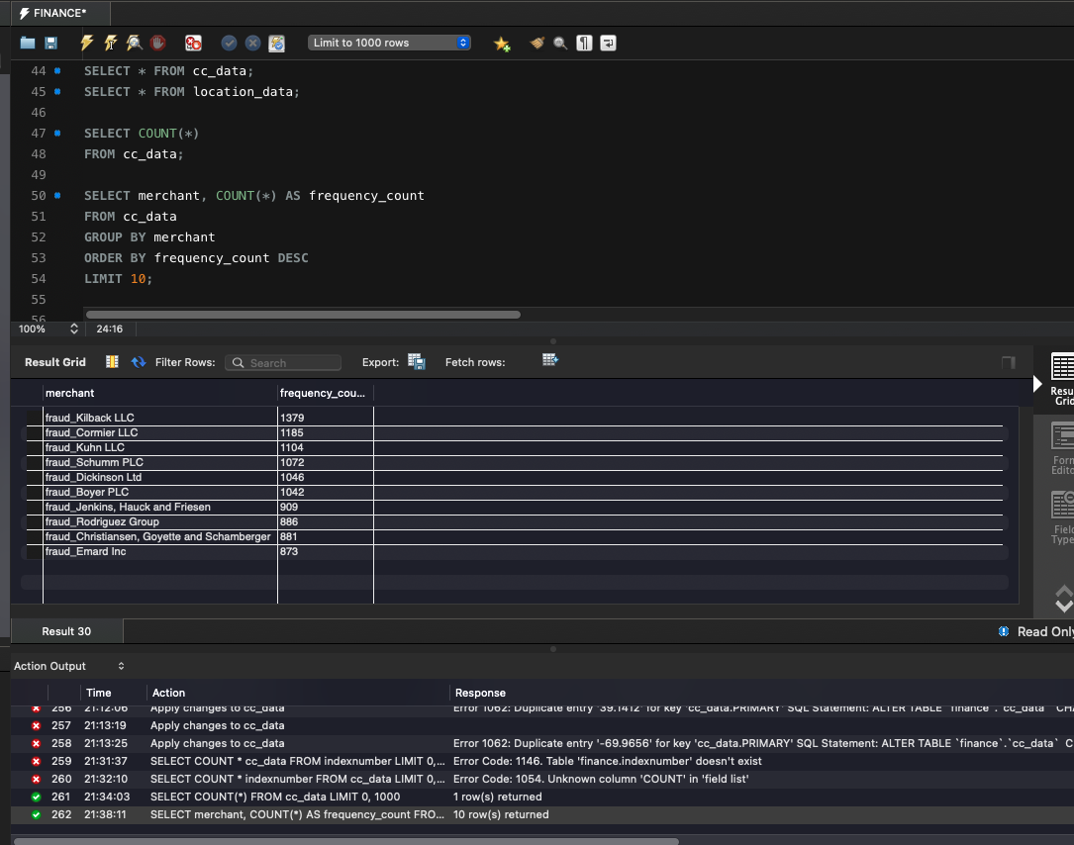

SELECT merchant, COUNT(*) AS frequency_count
FROM cc_data
GROUP BY merchant
ORDER BY frequency_count DESC
LIMIT 10;

SELECT category, AVG(amt)
FROM cc_data
GROUP BY category;
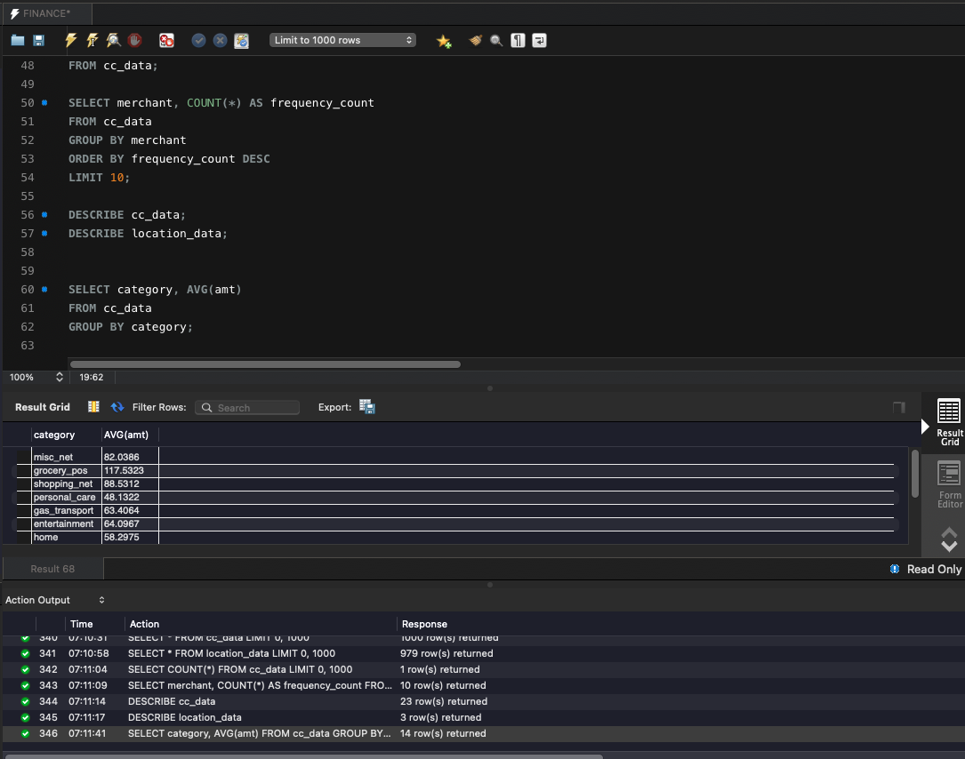

SELECT
COUNT(*) AS total_transactions,
SUM(fraud = 1) AS fraudulent_transactions,
ROUND(SUM(fraud = 1) * 100.0 / COUNT(*), 2) AS fraud_percentage
FROM cc_data;

SELECT
t.indexnumber,
t.transdate,
l.latitude,
l.longitude
FROM cc_data t
JOIN location_data l ON t.cardnumber = l.cardnumber;

SELECT city, COUNT(*) AS city_count
FROM cc_data
GROUP BY city
ORDER BY city_count DESC;

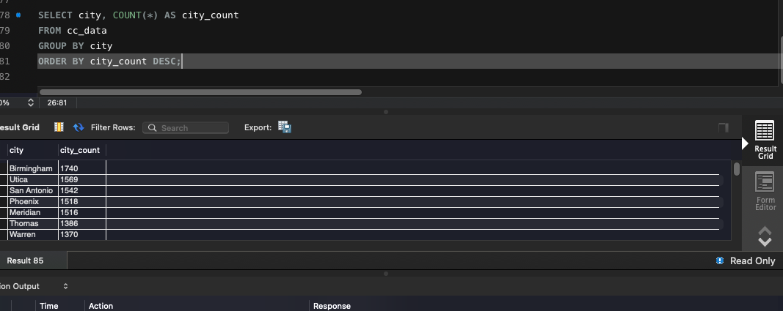

SELECT MIN(transdate) AS earliest_date,
MAX(transdate) AS latest_date
FROM cc_data;
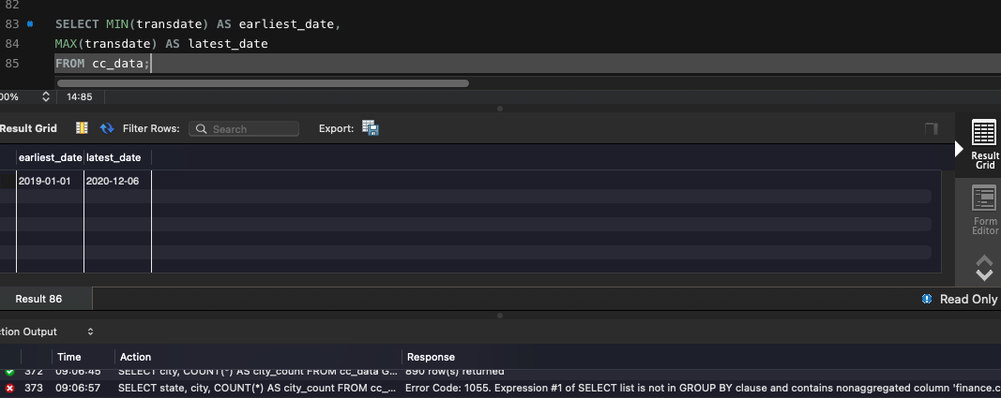
SELECT SUM(amt) AS total_fraudamount
FROM cc_data;
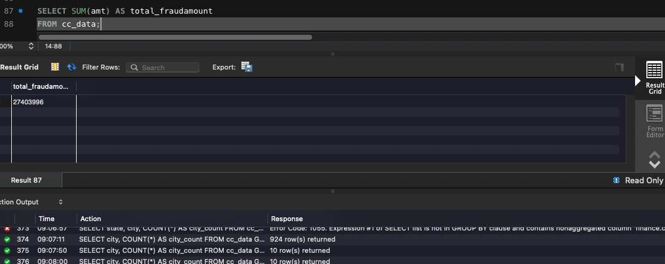

SELECT category, COUNT(*) AS transaction_count
FROM cc_data
GROUP BY category;
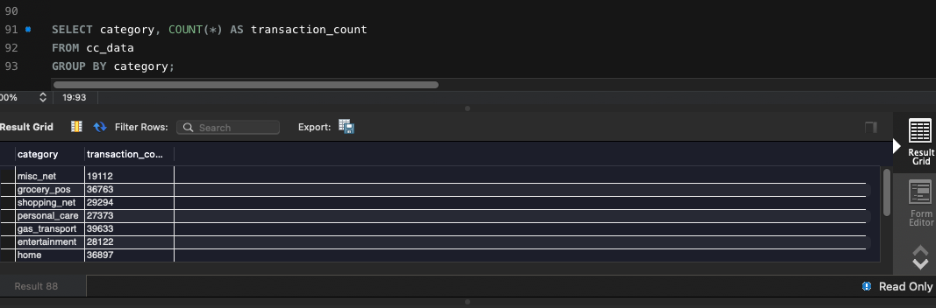

SELECT gender, AVG(amt) AS average_amount
FROM cc_data
GROUP BY gender;
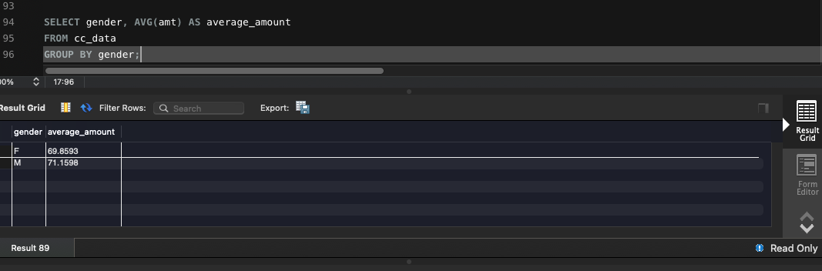

SELECT
DAYNAME(transdate) AS day_of_week,
ROUND(AVG(amt), 2) AS avg_transaction_amount
FROM
cc_data
GROUP BY
day_of_week,
DAYOFWEEK(transdate)
ORDER BY
day_of_week DESC;
